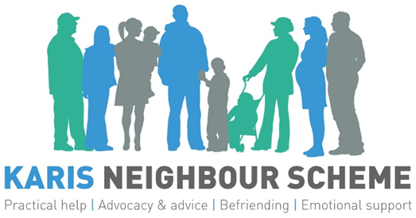

Complaints Procedure
1. We are always very keen to hear about your views and experience of our services. Clients, volunteers, employees and partners will be listened to with respect. Complaints will be taken seriously and dealt with quickly and thoroughly.
2. Unwritten complaints will be dealt with by the relevant project worker to whom they are addressed. If the complainant is still not happy then they may contact the CEO at the KNS office 0121 455 7524.
3. Should the complainant still not be happy with the action decided and want to take the complaint further, a written complaint should be sent to: harry.naylor@karisneighbourscheme.org or by post to:
Complaints
Karis Neighbour Scheme
c/o Church of the Redeemer
Monument Road
Birmingham B16 8UU
4. We will acknowledge receipt of your complaint within 2 working weeks. The aim is to investigate your complaint properly and give you a reply within 28 days, setting out how the problem will be dealt with. If this is not possible, an interim response will be made informing you of the action taken to date or being considered.
5. Should the person continue to feel that the complaint is not being dealt with effectively, KNS and the complainant will decide if an appropriate official body, such as ACAS or the Charity Commission, should be contacted to help resolve the problem.
6. Please note that at any time, a client or volunteer has the right to withdraw from the Karis Neighbour Scheme and Listening and Guidance projects.
7. The person making the complaint will be kept informed of progress at all stages.
8. All complaints will be treated in a private and confidential manner and stored according to our Privacy and Data Protection Policy. The CEO will keep a log of all complaints and outcomes.

Review Date: last updated January 2021

