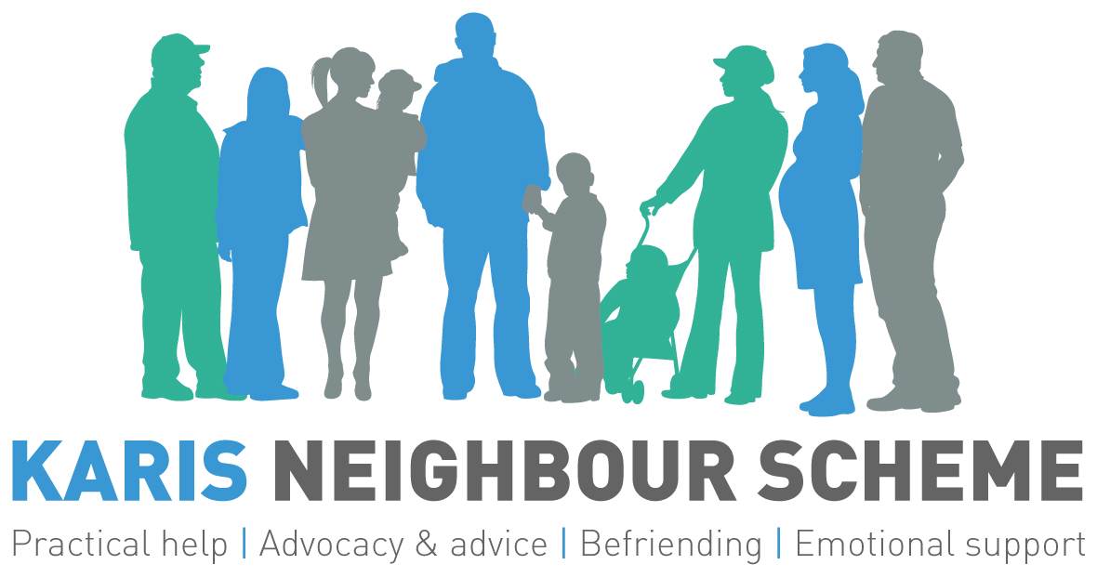

Gift Aid Declaration

Thank you very much for your gift towards our work as a charity, gifts like yours help us to offer much needed support to people in our community who are isolated or marginalised

Boost your donation by 25p for every £1 you donate

Gift aid allows us to reclaim the tax you pay for the current tax year. Your address is required to identify you as a UK taxpayer

Please tick to indicate:

I want to gift aid a single donation of £ to:

I want to gift aid all future donations to:

Karis Neighbour Scheme

I am a UK taxpayer and understand that if I pay less Income Tax and/or Capital Gains Tax in the current tax year than the amount of Gift Aid claimed on all my donations it is my responsibility to pay any difference.

Title First Name Surname

Full Home Address

Postcode

Date
Please notify us if you want to cancel this declaration,
Change your name or home address,
Or no longer pay sufficient tax on your income or capital gains

Contact Harry on 0121 456 3212 or 07952 765 794

